25.39: a) Nichrome wire:

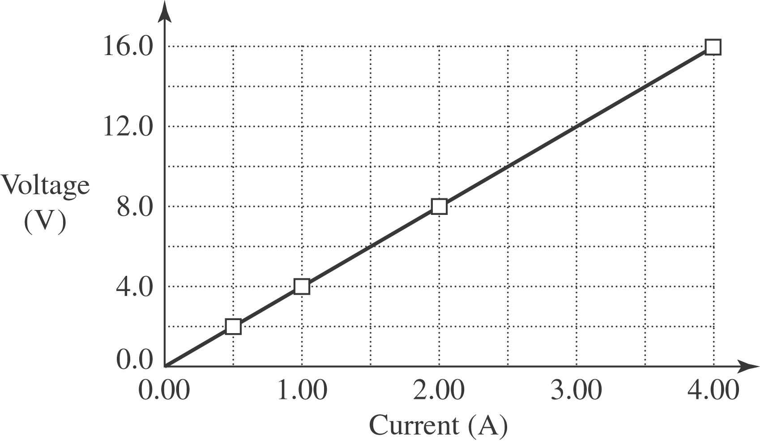

b) The Nichrome wire does obey Ohm’s Law since it is a straight line.
c) The resistance is the voltage divided by current which is 